**ACTION ITEMS STATUS REPORT**

|  |  |
| --- | --- |
| **Report Date** | **Project Name** |
| **February 2022** | **Automated In-Plant Line Inspection Reporting System** |

|  |  |  |  |  |
| --- | --- | --- | --- | --- |
| **Task, Actions Items, Milestones, Deliverables Overview** | | | | |
| **Task/Action Items / Milestones** | **Actions/ Solutions Performed** | **Status** | **Date Completed** | **% Complete** |
| * Learning the process of POSMD of how operation works | * DAI documentation (AIPLIRS) * Daily Receiving , Weekly Report, monthly report * Analyzing data gathered to be familiarized   *(see attached image below)* | On progress | 02/01/2022 - Present | 50 % |
| * Creating a page for the other function of AILPLIRS to be used | * Login page * POSMD, POSMS, RTD, MIO dashboard created   *( see attached image below )* | On progress | 02/01/2022 - Present | 5% |
| * Database structure | * Gathering some Data for the database structure | On progress | 02/01/2022 - Present | 50% |
| * Process Analyzation | * Interviewing the end-user for the confirmation of the process | On progress | 02/01/2022 - Present | 65% |
| * Budgetary Requirements | * Discussion about the budgetary requirements with IT Unit / POSMD using FORM C | On progress | 02/01/2022 - Present | 50% |
| * Meeting with the Project Manager, Process Owner and System Development Team | * Discussion about the progress of AIPLIRS and talk about the process created in IT terms including Database Structure, Process flow manual, Swimlane, Work Breakdown Structure | Done | 02/24/2022 | 100% |
| * Approved proposal process | * Swimlane, Database Structure, Output needed to be generated by the system | On progress | 02/28/2022 | 20% |

|  |  |
| --- | --- |
| **Version and Patch History** | |
| **Versions** | **Patch Updates Release** |
| January Changes and Updates | January 2022 |
|  |  |

|  |
| --- |
| Additional Comments |
| * While waiting for the meeting and other concern. POSMD provides some documents including to their process in operation and for the last AIPLIRS documentation * Gathering Data for the confirmation of the process owner * Checking the last website of AIPLIRS developed and at the same time checking the process flow of the system * Creating a Swimlane, Database Structure to be discussed and for Approval. |
| Recommendations |
|  |

|  |  |
| --- | --- |
| **Prepared by:**  **BAYOG, JUFREY NIÑO E.**  **Noted by:**  **MARIANNE JANE REPASO** | **Reviewed by:**  **JANUARY M. NONES**  **Approved by:**  **DR. EASTER F. OBLENA** |

**Login page**

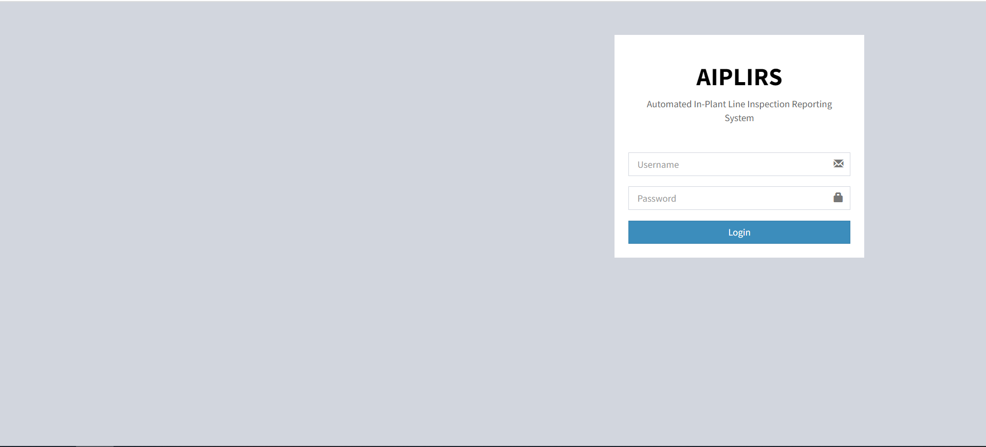

1. Designing on progress
2. Login is working, user will be redirected to the dashboard base to the role of their account

**Dashboard page (Meat Inspection Officer)**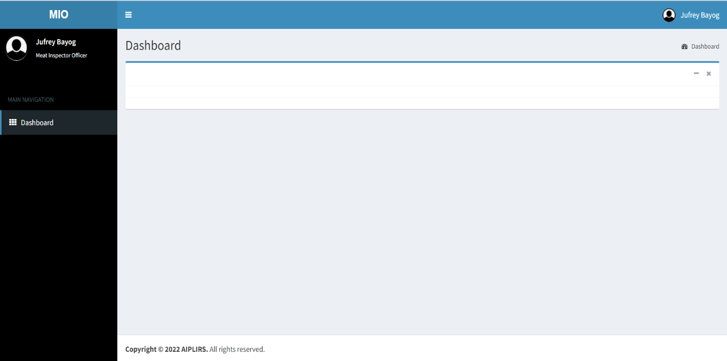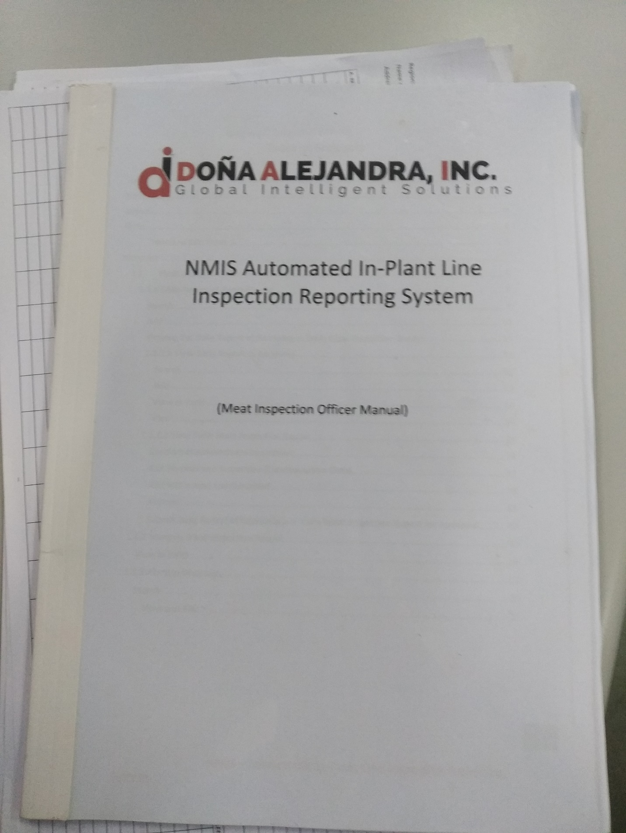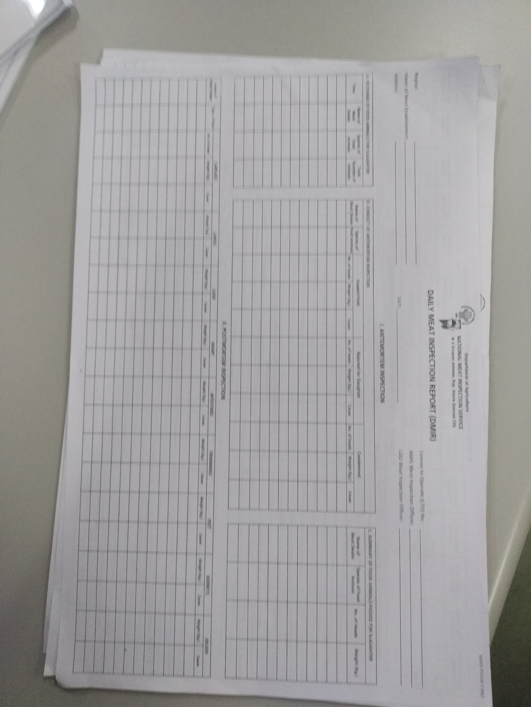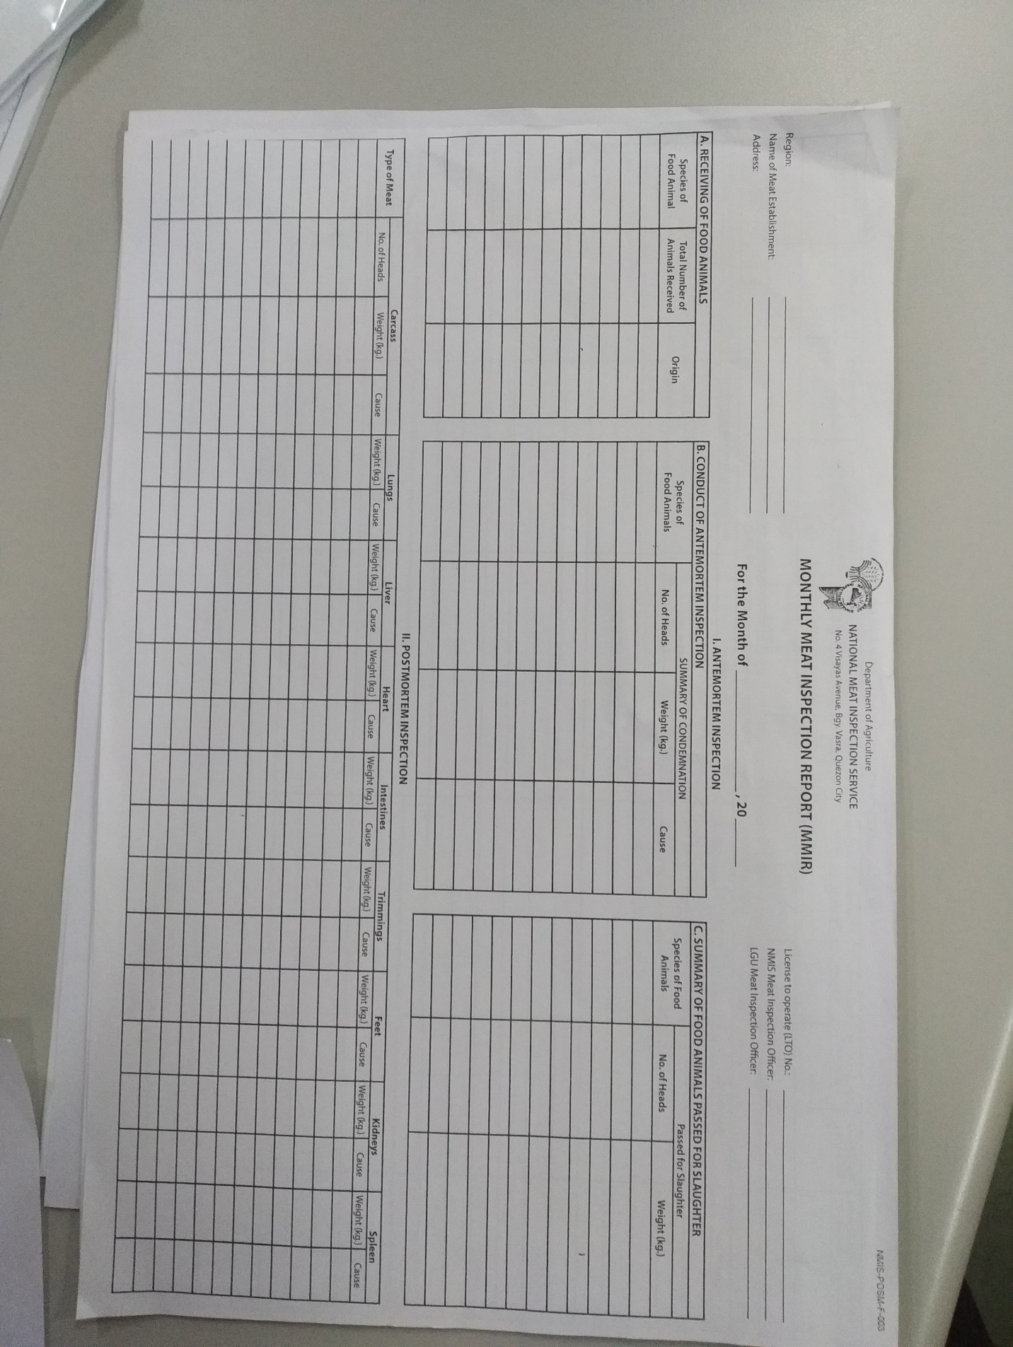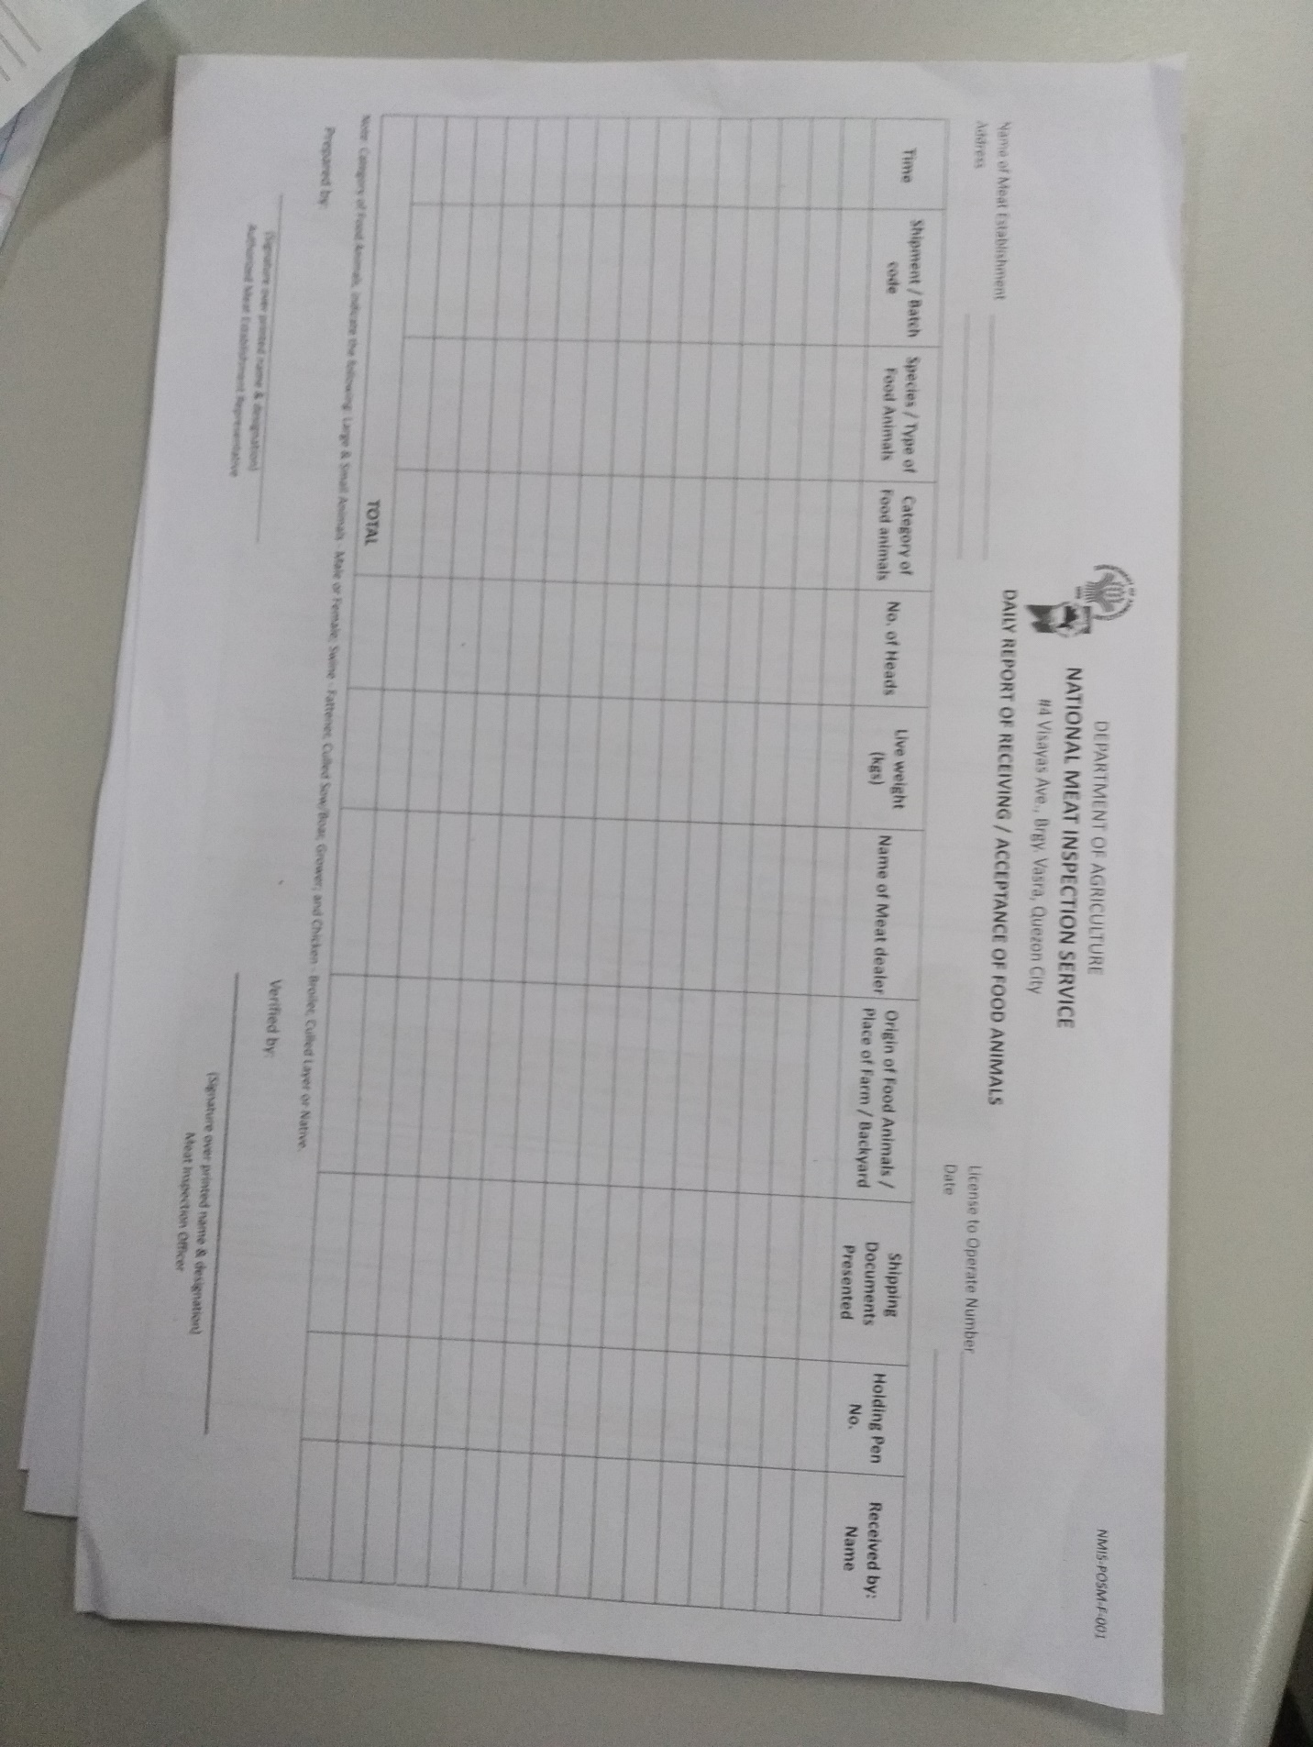

**AIPLIRS Swimlane**

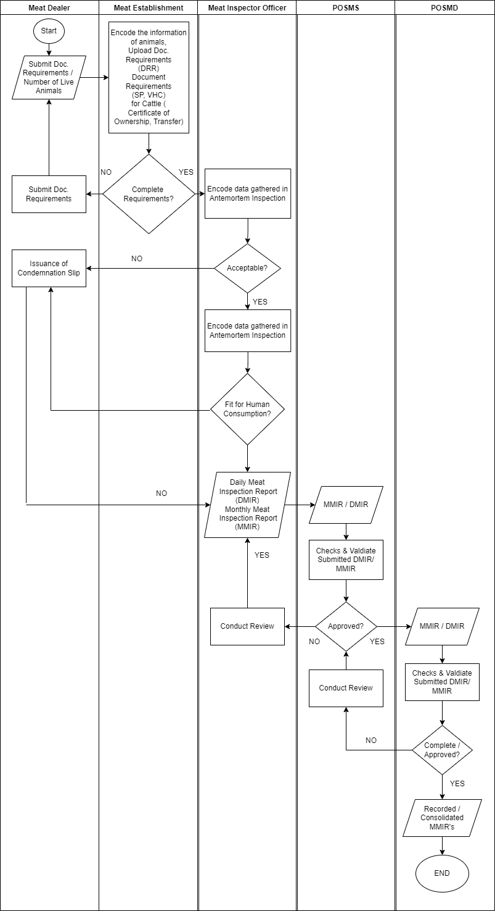

**AIPLIRS Database Structure**

